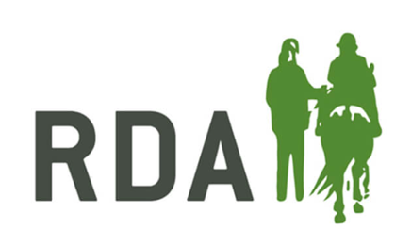
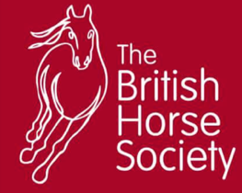
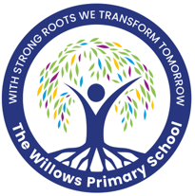
Changing Lives Through Horses Programme in Association
with Woodbridge Riding for the Disabled

TERM 1 – FOUNDATION KNOWLEDGE & CONFIDENCE
Relevant CLTH Awards this term:
- Being Safe Around Horses
- Grooming a Pony
- Knowing My Pony’s Feelings
- Feeding and Watering My Pony
- Leading My Pony
Week | Theory Focus | Ridden Focus | CLTH-Aligned Objective (Award + Life Skill)
1 | Yard safety, meeting the horses | Mounting practice | Being Safe Around Horses: To follow safety rules confidently (Responsibility)
2 | Horse behaviour & body language | Walk on/off | Knowing My Pony’s Feelings: To identify pony emotions and communicate calmly (Communication)
3 | Grooming basics | Steering cones | Grooming a Pony: To use grooming tools safely and build a relationship with the pony (Building Relationships)
4 | Leading a horse safely | Walk transitions | Leading My Pony: To lead safely with support and persevere through new skills (Perseverance)
5 | Stable routines | Balance games | Being Safe Around Horses: To understand stable areas and work responsibly (Responsibility)
6 | Feeding & watering | Independent walking | Feeding & Watering My Pony: To describe what a pony needs and communicate this clearly (Communication)
7 | Intro to tack | Steering shapes | Knowing My Pony’s Equipment: To name tack parts and show confidence using them (Confidence)
8 | Pony feelings & wellbeing | Walk route | Knowing My Pony’s Feelings: To recognise signs of stress and respond appropriately (Empathy/Building Relationships)
9 | Mucking out basics | Walk-only obstacle course | Stable Management Award: To work as a team to clean a stable (Teamwork)
10 | Riding position | Mounting independently | Beginning to Ride: To demonstrate a balanced position (Confidence/Perseverance)
11 | Review & quiz | Walk pattern | All Awards: To recall learning and communicate successes (Communication)
12 | Reflection | Fun ride | Celebration & Progress: To reflect on personal confidence growth (Confidence)

TERM 2 – SKILL BUILDING & INDEPENDENCE
Relevant CLTH Awards this term:
- Caring for My Pony’s Coat and Hooves
- Tacking Up My Pony
- Looking After My Pony’s Stable
- Learning My Pony’s Colours & Markings
- Developing My Riding Skills
Week | Theory Focus | Ridden Focus | CLTH-Aligned Objective (Award + Life Skill)
1 | Goal setting | Confidence ride | Personal Development: To set realistic goals and communicate them (Communication)
2 | Grooming for health | Steering accuracy | Caring for Coat & Hooves: To identify healthy coat/hooves (Responsibility)
3 | Tack-up basics | Steering independently | Tacking Up: To assist in fitting tack safely (Responsibility/Teamwork)
4 | Precision leading | Walk–halt transitions | Leading My Pony: To improve accuracy and persevere (Perseverance)
5 | Bedding & stable routines | Circles/serpentines | Looking After the Stable: To understand bedding types (Responsibility)
6 | Markings & colours | Balance exercises | Pony Identification: To describe markings confidently (Communication)
7 | Calm handling | Intro to trot | Building Relationships with My Pony: To show calm communication (Building Relationships)
8 | Pole work | Walk/trot transitions | Developing My Riding: To begin transitions with support (Confidence)
9 | Riding preparation | Patterns with cones | Developing My Riding: To steer with increased control (Perseverance)
10 | Riding outside | Longer route | Keeping Safe While Riding: To follow hacking rules (Responsibility)
11 | Self-assessment | Skills ride | Personal Development: To reflect on achievements (Communication)
12 | Journals | Skills circuit | Celebration & Progress: To recognise perseverance and growth (Perseverance)

TERM 3 – RESPONSIBILITY, LEADERSHIP & ACHIEVEMENT
Relevant CLTH Awards this term:
- Caring for My Pony’s Health
- Field Care
- Taking Responsibility on the Yard
- Final Riding Development
Week | Theory Focus | Ridden Focus | CLTH-Aligned Objective (Award + Life Skill)
1 | Safety + final goals | Warm-up ride | Personal Development: To set confident, responsible goals (Confidence/Responsibility)
2 | Health checks | Walk/trot transitions | Pony Health: To perform simple pony health checks (Responsibility)
3 | Independent tacking up | Loops/serpentines | Tacking Up: To tack up with increased independence (Perseverance)
4 | Leadership tasks | Walk/trot routine | Taking Responsibility on the Yard: To lead small tasks with peers (Teamwork/Leadership)
5 | Field management | Balance games | Field Care: To understand how to maintain safe fields (Responsibility)
6 | Gaits & movement | Trot (supported/independent) | Riding Development: To identify and ride different gaits (Confidence)
7 | Designing groundwork challenge | Obstacle practice | Personal Development: To plan activities collaboratively (Teamwork/Communication)
8 | Confidence strategies | Achievement ride practice | Resilience: To apply confidence strategies during riding (Perseverance)
9 | Hack safety | Mini-hack | Safety While Riding Out: To follow hack safety rules (Responsibility)
10 | Skill prep | Skills showcase | Final Riding Development: To perform riding skills independently (Confidence)
11 | Journals & awards | Fun ride | Reflection: To recognise relationship-building and personal growth (Building Relationships)
12 | Celebration | Certificates & photos | To celebrate success and share achievements (Confidence/Communication)

